Paper Title*
*Note: Sub-titles should not be used
1st Given Name Family Name*, 2nd Given Name Family Name*, 3rd Given Name Family Name^
* Affiliation, City, Country, Email address 1, Email address 2
^ Affiliation, City, Country, Email address 3

Abstract—Use this style for abstract. Do not use symbols, special characters, or Equations in Paper Title or Abstract. The summary is limited to one page including references. At most two figures can be used.
Keywords—Metantenna, Multiple Antennas

Summary
The 3rd Marina Forum (Mar-For 2023) on Metantennas and Multiple Antennas will be held on 14-16 August 2023 in Singapore. The program of Mar-For 2023 will continuously offer high-quality technical talks by renowned keynote, invited speakers, researchers, and talented students from all over the world. It aims to provide a broad forum of exchange for both academia and industry alike, for fostering collaboration between them. The forum will cover a wide range of topics related to metamaterials, metasurfaces, metantenna technologies, machine learning enabled methods for metamaterials and metantennas, collocated multiple antennas, array antennas, and relevant applications.
The main technical ideas or concepts are described in this section. Equations, figures are all contained in tables without border. The settings can be found in word Home -> Borders -> Borders and Shading.
Equations are placed within the table as below, either word equations or symbols can be added. Note the borders of the tables are invisible.
γ = α + jβ | (1)
Authors can copy and paste the equation tables to ensure the format is consistent.
$$v_{g}=\frac{dω}{dβ}$$ | (2)
There are up to two figures and one table can be inserted to this one-page summary. The figures are placed within tables with invisible borders. Since the submission of the summary uses pdf format, please carefully check the quality of the figures after the pdf conversion. Note the summary may be rejected due to low quality figures.
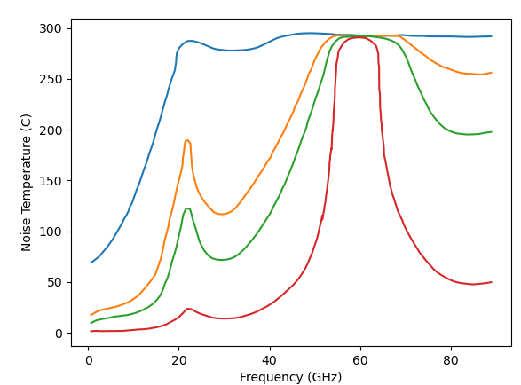
Fig. 1 Background noise temperature of sky over frequency, recreated from [1].
Comparison table can be added below. Please check the format after pdf conversion. The accepted one-page summary will be published online in the conference website.
Table of Important Dates
One-page Summary Submission# | 2 June 2023
Student Paper Contest Submission& | 9 June 2023
Student Interactive Forum Submission& | 16 June 2023
Conference Date | 14 – 16 August 2023
#: Summary is to be submitted via email, and will be reviewed.
&: The details can be found at http://www.marinaforum.org/index.html

Acknowledement
Funding support and other acknowledgements can be added in this section.

References

[1] D. M. Pozar, Microwave Engineering, 4th ed. John Wiley & Sons, Inc. 2011, pp. 668.

