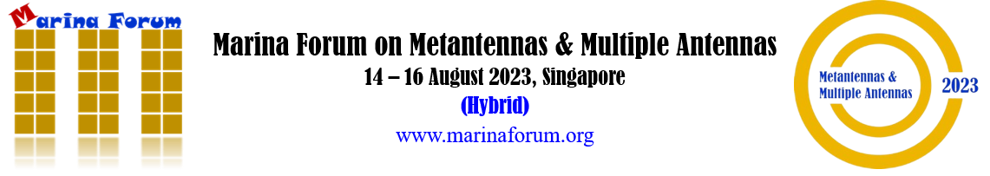

CALL FOR SPONSORSHIP

Dear Valued Sponsors,

The Marina Forum on Metantennas & Multiple Antennas will be held on 14-16 August 2023 in Singapore! This event is organized by IEEE Singapore RFID Chapter and sponsored by local academic and professional organizations as well as companies. The hybrid international forum provides the opportunity for exchanging information on the most recent advancements in the development of innovative metamaterial-based antenna technologies and multiple antenna systems.

Mar-For-Metantennas & Multiple Antennas 2023 will offer a rich scientific program of the highest quality with renowned keynote and invited speakers from all over the world and provide a broad forum of exchange for both academia and industry alike, with the aim of fostering collaboration between them. The forum will cover a wide range of topics related to metamaterials, metasurfaces, machine learning enabled methods for metamaterials and metantennas, collocated multiple antennas, array antennas, and relevant applications.

We would like to invite you to become a sponsor of Marina Forum 2023, which will provide you with one of the best opportunities to publicize your company, showcase your brand to the most influential engineering audience in microwave technologies, gain visibility, and maximize the exposure of your products and services to industry leaders, influential researchers, operators, vendors, investors, and key decision makers.

You are welcome to visit our Forum website at http://www.marinaforum.org for more information or contact our Logistics Chair and Technical Program Co-Chair Dr. Terence See at spsee@i2r.a-star.edu.sg.

In appreciation of your support, sponsors will have their company logo (linked to company site) displayed on our Forum website, as well as during the event and on all collaterals.

We look forward to your support to this event!

Prof. Zhi Ning Chen Dr. Terence See
General Chair Logistics Chair &
Technical Program Co-Chair
Registration Form

Sponsorship Amount (min equivalent to USD 1,000): Currency:

Company Name:

Company Address:

Contact Name: Designation:

Telephone: Mobile Phone: Fax:

Email:

Signature: Company Stamp:

Date:__________________________________________

Payment Method (please choose ONE): Cheque/Internet Banking/Telegraphic Transfer

Payment Information:

Cheque Payment: Cheque to be crossed and payable to “Exomnia Events Pte Ltd – Marina Forum 2023”. Please indicate the Forum name “Marina Forum” and Registrant’s Name at the back of the cheque. The cheque can be mailed to “Institute for Infocomm Research” Address: 1 Fusionopolis Way, Connexis South Tower #21-01 Singapore 138632 (Attn: Terence See Shie Ping).

Internet Banking/Telegraphic Transfer Payment: Please indicate the beneficiary name “Exomnia Events Pte Ltd – Marina Forum 2023” in your bank document. Amount must be nett of all bank charges.
Account Name: Exomnia Events Pte Ltd – Marina Forum 2023
Account Number: 066-904510-7
SWIFT Code: DBSSSGSG
Bank Name: DBS Bank
Bank Address: 12 Marina Boulevard, DBS Asia Central, Marina Bay Financial Centre Tower 3, Singapore 018982

