AISYWC-2019
All India Student –Young Professionals –Women in Engineering Congress

AISYWC, the annual hallmark event of IEEE India Council was organized most vibrantly and fruitfully under the roof of CMR Group of Institutions, Hyderabad from 28 to 30 September. The All India Student –Young Professionals –Women in Engineering Congress founded in 2000 has grown over the years from All India Student Congress to AISYWC turning itself to be one of the biggest events in calendar for IEEE members. It is an amalgamation of inventors, professionals, entrepreneurs, visionaries and some of the greatest minds of the country. By bringing together these brilliant minds from all walks of life, the AISYWC envisions to provide its members a platform with dynamic career opportunities, path to connect with academicians, scholars and entrepreneurs from diversified field along with a reward for blending in cultures. The Congress provides three days of connection, inspiration, motivation, effective networking, personal development and skill building for hundreds of students/young professionals. Expert speakers lead workshops, seminars on recent technologies, including businesses and entrepreneurship, work life balance and more. The Congress offers incredible opportunities for business networking, professional development and personal growth. Every year the AISYWC is held at different venues which gives a glimpse of what the host section has to offer along with the opportunity for each and every delegate to re-evaluate their capabilities.

In its successful history of 10 years, the congress has been organized wonderfully at different sections which include Gujarat, Bangalore, Madras, Kerala, Delhi and UP sections, most recently being hosted again by IEEE Bangalore Section at Vidya Vikas Institute of Engineering and Technology, Mysore during the time span 28-30 September 2018.

This year AISYWC was hosted by IEEE Hyderabad Section at CMR Group of Institutions, Hyderabad from 28th to 30th September.

THEME: The theme of AISYWC 2019 was to acquire knowledge, Ideate to innovate, Strengthen skillset, Youngsters on a learning spree, weaving networks to nurture, Collaborate to change the world.

VISION: To envision the delegates to develop into engineers who are an asset to the society both technically and socially catering to the needs of the people.

MISSION : To provide its members a platform with dynamic career opportunities, path to connect with academicians, scholars and entrepreneurs from diversified fields and a rewarding experience of blending cultures offering an entry to all domains of technology, social activism and entrepreneurship.

OBJECTIVES:
- All Career Opportunities under one Umbrella: A platform that envisions in creating new opportunities amalgamated with exquisite IEEE resources for career development of budding engineers.
- Channel to Connect, collaborate and create: To help young minds to find the right path amidst all the tracks and channelize their ideas for the betterment of next-generation technology.
- Member grade oriented session tracks: IEEE members are the building blocks of this magnificent society. Tis AISYWC we aim to provide sessions that could assist members in utilizing plethora of IEEE resources for their career and skills enhancement.

AISYWC Events

Day 1

The Flagship event of IEEE India Council brought in with the conjoined effort from the IEEE Hyderabad Section bore fruit as the phase 2 registrations closed within the first week of September. Enormous number of participants from all of the 11 sections registered owing to nearly 700+ registrations. The meet as scheduled saw the accommodation of delegates from far and near at Grand Lotus Hotel and Sri Simran Park Hotel on 27th of September. There was a completely unexpected drizzle but both the organizers along with the participants considered that as a welcome note to the “City of Pearls”. The success of a versatile congress is condemned by the intellectual gathering and delivery of knowledge. The online registrations conducted in 2 phases closed soon as the expected participant rate and the delivered one differed in huge numbers. The Registration desk opened up as soon as the delegates were transported to the venue which is a 45 minute ride from the place of stay. The registrations began from 8 AM IST to nearly 5 PM IST. The participants were provided with an ID card, food coupons and a Kit consisting of the schedule, a notepad along with a pen and some notes regarding an upcoming session on DSP.

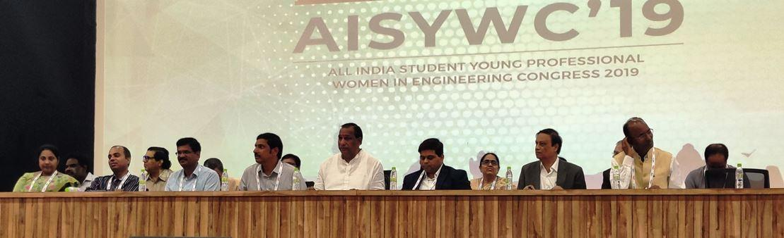

The 19th edition of IEEE’s hallmark annual event, All India Students, Young professionals and Women in engineering Congress (AISYWC) was inaugurated with much fanfare at CMR Group of Institutions, Hyderabad on 28th September 2019. The event saw a host of distinguished guests, prominent among which were Sri C H Malla Reddy, Minister of Labor, Employment, Women and Child Development from 2019 in Telangana, Mr. M Janga Reddy, Director of CMRIT and Dr. CH. Gopal Reddy, Secretary and Correspondent CMRGI. From the IEEE gallery of stalwarts, there was Dr. S N Singh, Chair of IEEE India Council, Dr. Rajashree Jain, Vice Chair of IEEE Student Activities, Sri N. Venkatesh, Chair of Hyderabad Section and Senior Vice President, Advanced Technologies and Dr. Y. Vijayalata, Chair of the Congress, Dr. Amit Kumar, Vice Chair of IEEE Hyderabad Section and Sri Vamsi Krishna J, Vice Chair of IEEE Young Professionals and Organizing Secretary of AISYWC 2019.

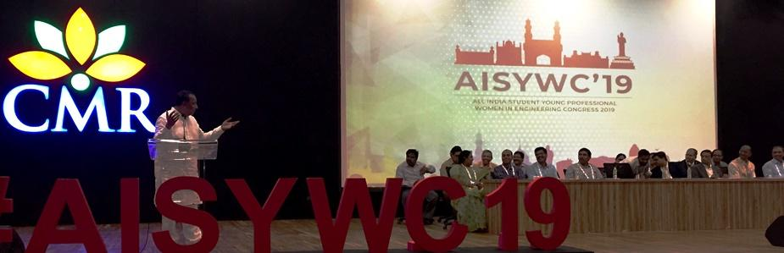

The program was given an auspicious start with the ceremonial lighting of the lamp. This was followed by an overview of the Congress delivered by Dr. Vijayalata in the capacity of Congress Chair. After she walked them through the Congress itinerary, Sri. N Venkatesh addressed the gathering. Subsequently, Dr. S. N. Singh appreciated the efforts put in by the volunteers and participants alike in making this meet possible and hoped for its grand success. Sri. CH. Gopal Reddy then warmly welcomed all the delegates to the City of Pearls and wished them a comfortable and enlightening stay in Hyderabad. Also the Director of IEEE India Operations Mr. Harish Mysore graced the occasion and wished it to be a grand success.

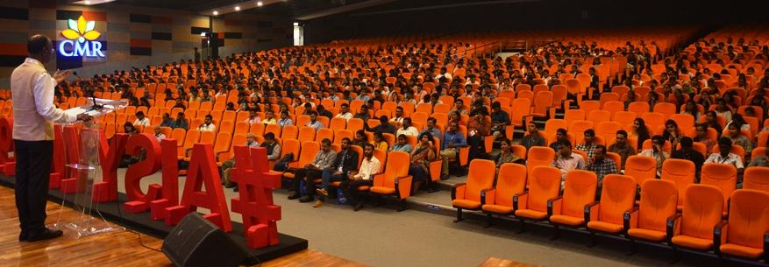
The distinguished guest of honor for the evening was Sri C. H. Malla Reddy, currently Minister of Labor, Employment, Women and Child Development for the state of Telangana who gave a ferocious speech in encouraging the youth to utilize ample opportunities by hard work which is destined to bear fruit in the long run.

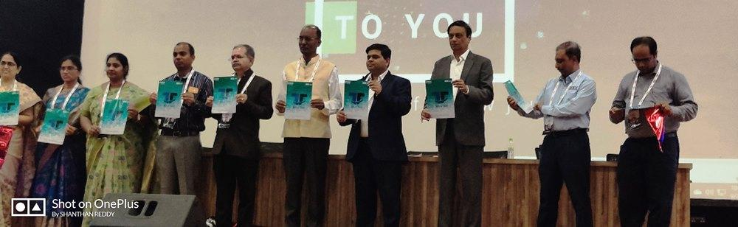

The inaugural ceremony concluded with a Vote of Thanks by Dr. Amit Kumar, Vice Chair of IEEE Hyderabad Section.

IEEE Tell-a-Tale, a first of its kind initiative was also launched on the first day of AISYWC 2019.Tell-a-Tale is a project that aims to share the unique and inspiring experiences of volunteers who have worked hard to organize events and conferences of IEEE. It aims to motivate the next generation of volunteers and provides a platform for support and experience sharing. The logo was unveiled by the host of IEEE India Council dignitaries which includes Dr.SN Singh, Chair, IEEE India Council, Dr. Harish Mysore, Director, IEEE India Operations, Mr.Puneet Mishra, Secretary, IEEE India Council, Dr. Rajashree Jain, Vice Chair of IEEE Student Activities and by the congress organizing committee.

After inauguration the meet was progressed by the first Keynote Address on DSP through Digital Filtering by Dr. GVV Sharma, an eminent scholar who received his Ph.D. in Electrical Engineering from IIT Bombay and did his M.Sc. (Engg) from IISC Bangalore and Btech from IIT Guwahati. He mainly works on wireless technologies but has a passion for developmental engineering. The address primarily focused on the programming language Python which could also be implemented using an android phone by using Termux, which is an app in playstore.The session was really interactive which involved students raising questions and he shot down all of them with his quick wit. The most catchy point of the session which the delegates felt or themselves is his saying that “Science is the beginning then Art takeovers”. So he indirectly told the students to widen their horizons and to look for brighter dimensions.

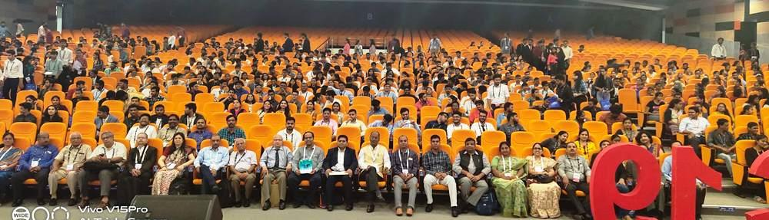

Nextly we had an Ice Breaking Session which was led by Mr.Jeet Dagha who also happens to be the R10 lead for IEEE Day Celebrations 2019.The session started with him briefing on what to be done and then finally took over to all the special discounts that the newbies could use to avail IEEE membership. Finally with a bang Ms. Dimple Khilwani, an India Council Volunteer took over to an unexpected quiz program in which the right answers were given IEEE goodies. There was also another round of goodie giving that promoted networking among different sections and the delegates who had made connections nearly to 5 were again given a hand full.

After the fun round, the congress dispersed for lunch which had in it the aroma of the ethnic cuisines made just for all the delegates to have their tummies along with their hearts content.

After the break, the session was on IEEE Microwave Theory & Techniques- Initiative & Opportunities for Young Minds by Dr.N Srinivasa Rao, a Ph.D. holder in BioElectromagnetics from JNTUH who is also a life member in IETE, ISTE, ISI and so on. Throughout his career, he had many publications and has attended a lot of international conferences. He began with the history of how JC Bose demonstrated the radio theory. His presentation also focused on how the students could avail the MIC & Antennae trainer kits to perform experiments and get an insight into the same. Nowadays the scenario has completed changed with the advent of software’s and is much simpler by all means. He also emphasized on the IEEE MTT Society which focuses on the same domain and wished more students would utilize the same opportunity.

The next session was by Dr.Sulakshana Chilukuri on The Importance of research in RF and Microwave Engineering. An apt speaker for the same, she holds a Ph.D. from NIT Warangal and even worked as a Postdoc Research Fellow at the University of West of Scotland, UK. She is presently the Head of Vardhaman Student Satellite Mission leading students working on VSAT.She primarily focused her talks on how her field still remains untouched to the larger part of the group. Her growth every time she was placed in an entirely different strata and her evolution to who she is today. Her talk would motivate anyone who is the least interested to at least peek in to what’s new in the domain. Finally she wished for more students to opt for the same topic and wished every student present there to have a bright future ahead.

Entrepreneurship is kind of the new “Buzz” in today’s world.AISYWC wasn’t short on that too. The next session was on Entrepreneurship in Global Perspective by Mr. Murali Bukkapatnam who is also an entrepreneur himself of Volksy Technologies who provides an executive leadership focusing on growth strategy, finances, risk management and compliance. His words would have rang a bell in all the delegates’ hearts to at least try for something which is as demanding and exploring at the same time. To learn entrepreneurship one should not go far but start from our own homes, the best example being our own Moms who never say ‘No’ to any of the demands we ever make. The anatomy of an entrepreneur consists of the Mind frame, Heart frame and the Guts Frame. All of these frames can definitely mold in oneself a true entrepreneur. The session ended with a huge crowd waiting to enter the corporate world.

The next session was on Failures, Learning and Experiments: Achieving Something Meaningful by Mr. Puneet K Mishra who has been with ISRO Satellite Centre since 2004 and is presently heading Satellite Antenna Characterization, Test & Design Section. He has a rich experience of RF characterization of 31 satellites operating from UHF to Ka Band. The recent launch of Chandrayaan 2 triggered a very silent audience for Puneet Sir. He started by stating a life experience in which he messed up in one of the situations but was never punished because he was honest about it.He added that life is all about taking risks, it’s not for the faint hearted, it’s for those who are willing to make mistakes and then rectify it in the long run. Most of the Q&A revolved around the mishaps that happened with Chandrayaan but he was happy to answer them all.
After a full on Tech Session, the delegates were given the opportunity to laugh to their heart's content through a standup comedy by Mr.Sudeendra Koushik which revolved around his native place Bangalore. The road of comedy stretched from Mysore Pak to silk saree to becoming a millionaire by being a billionaire first and getting married after that.

The Host Institution didn’t seem to get contented with the hospitality given to delegates that they performed a cultural night starting from traditional dances including folk to hip-hop and beat boxing. The stage also witnessed talents from different sections whose beatboxing could be termed as “phenomenal’. Several Dance groups from CMR College named Obvious & Illuminators rocked the whole stage and left the delegates in realm of ecstasy.

There was also an Award Ceremony that took place in remembrance of the founder of Hope Foundation Mr.Pralhad P Chabaria to women who have showed notable contributions to the society in terms of their work. The Best Female Professional Award went to Dr.Rajalakshmi for her excellence in technology and her area of expertise. The Best Female Outgoing Student Award went to Ms.Shubhi Serin also for her efforts to equalize opportunities in programming for both males and females. Both received a medal and a cash prize worth 1.25L for their amount less contributions.

After the ceremony, all the participants moved for the Banquet Dinner and after a hearty meal proceeded to the bus depots that drove them back to their hotels with new ambitions for the next 2 days of the congress.
Day 2

The second day of the Congress started with a positive vibe of turning an obstacle into an opportunity. This positive vibe was spread by Dr. Sandhya Kode Director, Training and Development, IIIT Hyderabad. She began the session by explaining how to turn obstacles into opportunities. Ability to learn and life long journey, collaboration, communication skills, integrity leveraging the technology and leveraging strength were some of the points shared by her. She insisted on some important points such as the right way to treat other people is how you want to be treated and choosing the right thing in difficult situations is the real life. She concluded her speech by motivating the gathering to strengthen the core, exercise, build resilience especially adversity quotient to turn obstacles into opportunities.

Mr. Anil Rachamall Social Activist and Founder End Now Foundation gave a talk on Digital wellbeing - building a positive digital footprint session. He started his session by saying that social media is an entertainment and he insisted the young minds to create new things rather than wasting time in social media. He discussed the pros and cons of social media and said that social media makes us antisocial. He shared more information on the Gallup, social media statistics, screenage world and shared some facts about dopamine and tips to become social. He finally ended the session with a quote ‘Disconnect to reconnect’.

The second day noon started with the TEMS panel discussion with 5 eminent speakers. The panelists are Dr. Sudeendra Koushik, Mr. K Gopalakrishna, Mr. J Krishnaswamy, Mr. Bala Prasad and Mr.Abhishek Appaji was the moderator for the panel discussion. The discussion was based on the Employee vs Entrepreneur vs consultant and the benefits of joining TEMS. Mr. Bala Prasad gave more information on the 5G technology and on bringing the technology together in the form of a chip.Dr. Sudeendra Koushik discussed about the half-life of education and the Four E’s i.e. education, experience, expertise and exposure. Information on collaboratory work was given by Mr. K Gopalakrishna. Followed by him Mr. J Krishnaswamy discussed more on technology, employee, consultant, entrepreneurship and intrapreneurship.

Mr. Atul Negi Professor Ph.D., University of Hyderabad, was the next speaker of the day. His session was based on the future science artificial intelligence and AI for social good. He detailed about the Algorithm 802.11, IEEE standards, hype cycle and shared more information on deep learning and its applications , machine learning and the 17 parameters for sustainable. AI in prediction that includes the case study in agriculture using microboys and agrobots. And added that technology can increase the yield. He mentioned that India is one of the few countries in the world which made AI policies.

Followed by that Mr. N Venkatesh Chair. , IEEE Hyderabad Section, handled a session on Wi-Fi connectivity for remote sensing drones. He started by briefing about drones, downlink, uplink battery life and radio link connection of the drone. He explained about rate vs range, LoRa, and STBC and concluded by adding more points to geoscience and remote sensing society.

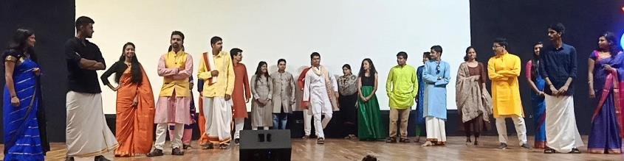

The Most awaited enthusiastic cultural night started with the Rock Band by the host institution CMRIT. The delegates from different sections were dressed in their traditional attires and showcased their talents. The section performance started with Ganesh vandhana and the traditional Kathak dance. The participants from various Zones made the night fun filled and the gathering enjoyed to their core. The cultural night ended with the celebration of the traditional Bathukamma festival of Telangana.

LM Track

The Life Members (LM) track was organized on Day 2 of AISYWC 2019.

Prof Sankaran explained how the LM track materialized this AISYWC, explaining how Region 10 organizes AISYWLC (includes all three affinity groups) and narrating the story of how he and other LMs pushed for having an LM track at the All India Congress on the lines of the Region 10 Congress.

The proceedings began by celebrating the birthday of one of the LMs present, Dr. Vidyasagar with the ceremonial cake cutting. This was followed by a round of brief introductions before beginning the sessions. Mr. N Venkatesh, Chair, IEEE Hyderabad Section, welcomed all the Life Member delegates and thanked them for taking efforts to visit Hyderabad. He also invited them to the cultural evening and dinner that would follow the LM sessions.

Mr. V. Prasad Kodali delivered the first talk on ‘IEEE Life Members- a 130 Year History of Philanthropy.’ Mr. Kodali is an IEEE member since 1963, a Life Member since 2006, and has conducted extensive research on the history of Life Members in IEEE worldwide. Who better than him to conduct a session explaining the growth of LMs in IEEE. He explained the timeline of how the predecessor organization of the IEEE, namely the American Institute of Electrical Engineers (AIEE) introduced a Life Membership or Associate Membership in 1884. In that time, a one-time payment was sufficient to become an associate member. In 1947, IRE introduced Life Membership. When the IRE and AIEE merged to form IEEE, a formal Life Membership was created in 1963. The bylaws for the same (Bylaw 102.2) were committed to paper in 1971 and there has been no change in rules for LMs thereafter. Prof. Kodali explained that in the early days, LMs majorly contributed towards philanthropy, and their main focus was on funding education for students. He then elaborated upon the IEEE Life Member Fund and how the LM Funds have been put to use so far in myriad applications ranging from History Centers and Museums, to the IEEE Global History Network. He tried to hit home the point that a retired professional has a lot of time at his/her disposal and yet there are very few Life Members (citing Dr. Vidyasagar as an example) who contribute so much or win prestigious IEEE tech awards.

Day 3

The first session of the final day congress was taken by Mr. Vamsi Krishna J & Mr. Abishek Appaji on the topic “Crossing the chasm from Student to Studentpreneur”.Mr. Vamsi Krishna J shared his experience working with stumax and Mr. Abishek Appaji shared his experience in MIT. They taught what innovation is and the difference between the need vs want. This session motivated the audience and inspired them with much more confidence to go ahead and achieve their goals.

The next session was handled by prof. ML Sai Kumar Past Dean of Academics, Institute of Public Enterprise about the Make a Difference (MAD). He interacted with the delegates by asking questions and motivated them playing the videos of real time examples of people who really made a difference. He advised the gathering to think beyond the books and make a difference to someone’s life. This was followed by the launch of Skill Connect Program website by Dr. Amith Kumar, Mr. Bala Subramanyam and Mr. Ravishankar. Mr. Dev Jothi briefed the benefits, takeaways and the various phases of the skill connect program.

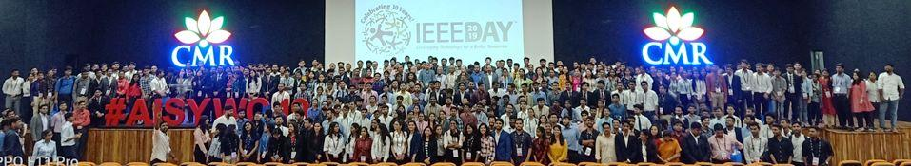

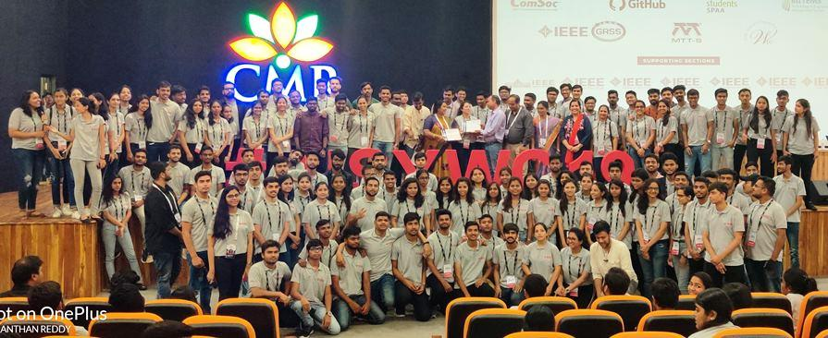

The flagship event of IEEE India Council AISYWC 2019 came to an end with valedictory session and certificate distribution followed by group photo with Congress T-shirt. The vote of thanks was given by Mr.J.Vamsi Krishna. The biggest event on the calendar for IEEE members in India was a remarkable one by achieving the mission and vision of AISYWC 2019 successfully. The Congress ended with Lunch & Wrap up from event place to Hotel.

More photos of the event are available at https://photos.app.goo.gl/CR9icUjT4QtKFCQD7
Report by: IEEE Hyderabad Section & IEEE AISYWC Working Committee (Dr Vijayalata Reddy, Congress Chair - AISYWC & N Venkatesh,Chair - IEEE Hyderabad Section)
Coordinated by: Dr Amit Kumar, VC-Conferences, Mr. Vamsi Krishna J, VC-Young Professionals & SCT &
Dr Rajashree Jain, VC - Student Activities

