Executive Summary on AISYWC 2018

2018 version of IEEE India Council’s flagship event-All India Students-Young Professional-Women in Engineering Congress was hosted by IEEE Bangalore Section at Vidya Vikas Institue of Engineering and Technology, Mysore on Sep 28-30. Nearly 450+ delegates attended the congress including speakers, India Council Execom members, Bangalore Section Execom Members. This year theme of the AISYWC was “Aspire, Ideate, Sychronize, Widen Thpught, Capture the Goal”. This was the largest AISYWC till date. IEEE UP, Kerala, Gujrat, Hyderabad, Madras, Pune and Kolkata sections supported the congress. AISYWC 2018 was financially supported by IEEE HAC, IEEE GRSS, IEEE MTT-S, IEEE PES, IEEE ComSoc, IEEE TEMS, IEEE YP, IEEE WIE, Entuple & Intel. 60 Speakers from Industry, Academia, Startups, Legal, IEEE Societies and Committees gave talks on various topics and mesmerized the delegates. AISYWC 2018 has introduced 2 new tracks namely Branch Counselors track and Hands on Track in addition to Students, YP and WIE Tracks. In another first AISYWC 2018 delegates were accommodated in 3 star hotels & cultural program were conducted on both days.

Attendees in AISYWC 2018
Detailed Report on AISYWC 2018

Day 0 (27 September’18)
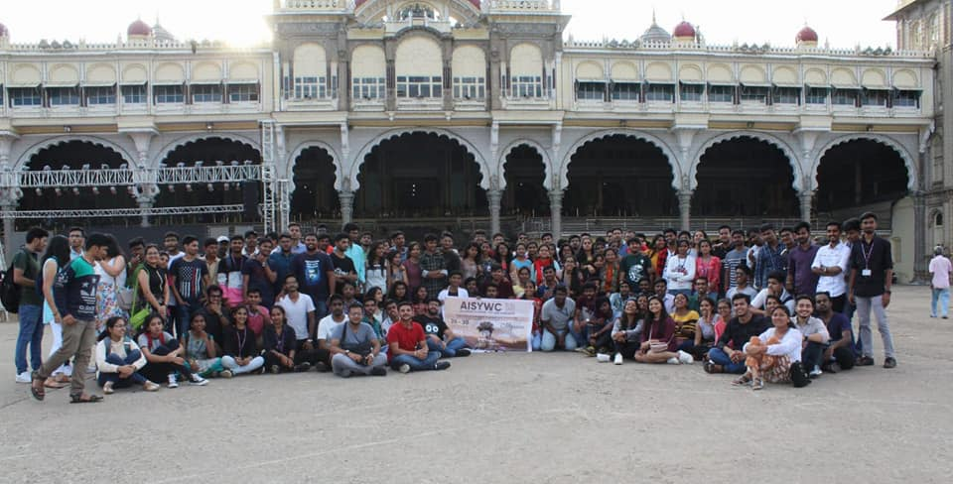
The day before the conference started with all delegates checking in to their hotels at 12.PM and then there was a half a day trip arranged for the delegates by the AISYWC team to show the culture and heritage of Mysuru. At 2:00 PM, buses were arranged from all the respective hotels to the Mysore Palace, where the delegates from all around India visited the culture rich palace of Karnataka. Followed by the palace visit was YP Meet up arranged at the palace premises, where all the delegates had an ice breaking session to get to know each other and bond with people from different sections. After the palace, the delegates were taken to Chamundi hills, where they relaxed and saw the amazing view of the entire Mysore city and the sunset. The delegates were then taken to the famous shopping street of Mysuru called Devraj Urs road where they were provided with the famous Mysuru Pak and Samosas. After shopping they were picked up and then dropped to their respective hotels to gear up for the amazing 3 days.

Day 1 (28 September ’18)

Inauguration
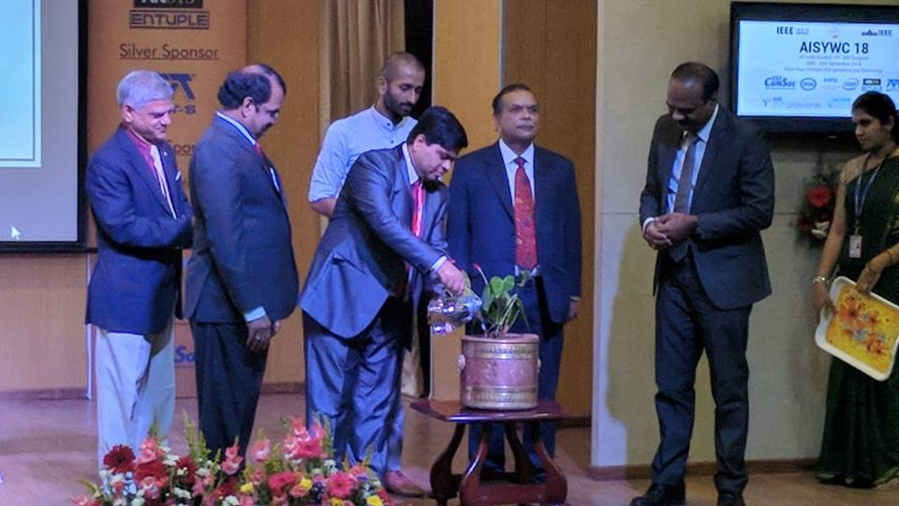
The Annual Flagship event of IEEE India council and IEEE Bangalore for the year 2018-19 that is All India Student - Young Professionals- Women in Engineering Congress (AISYWC) inauguration ceremony began after the registration process where the kits were distributed to the participants. The dignitaries were escorted to the dais with the state anthem. The program began with a significant notion of watering the plant and an invocation song. Mr. Puneet Kumar Mishra, General Chair, AISYWC’18 briefed out the AISYWC’18 statistics and explained how tremendously unique is this year’s AISYWC and welcomed all the delegates to this amazing event. Ankita Ks, Secretary of AISYWC’18 introduced the honorable chief guests Dr. M Annadurai and Dr. Justice N Kumar and they were felicitated with great honor.

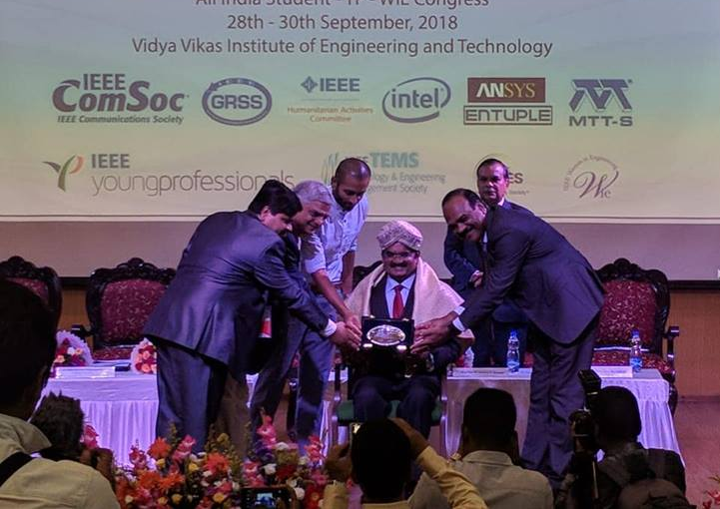
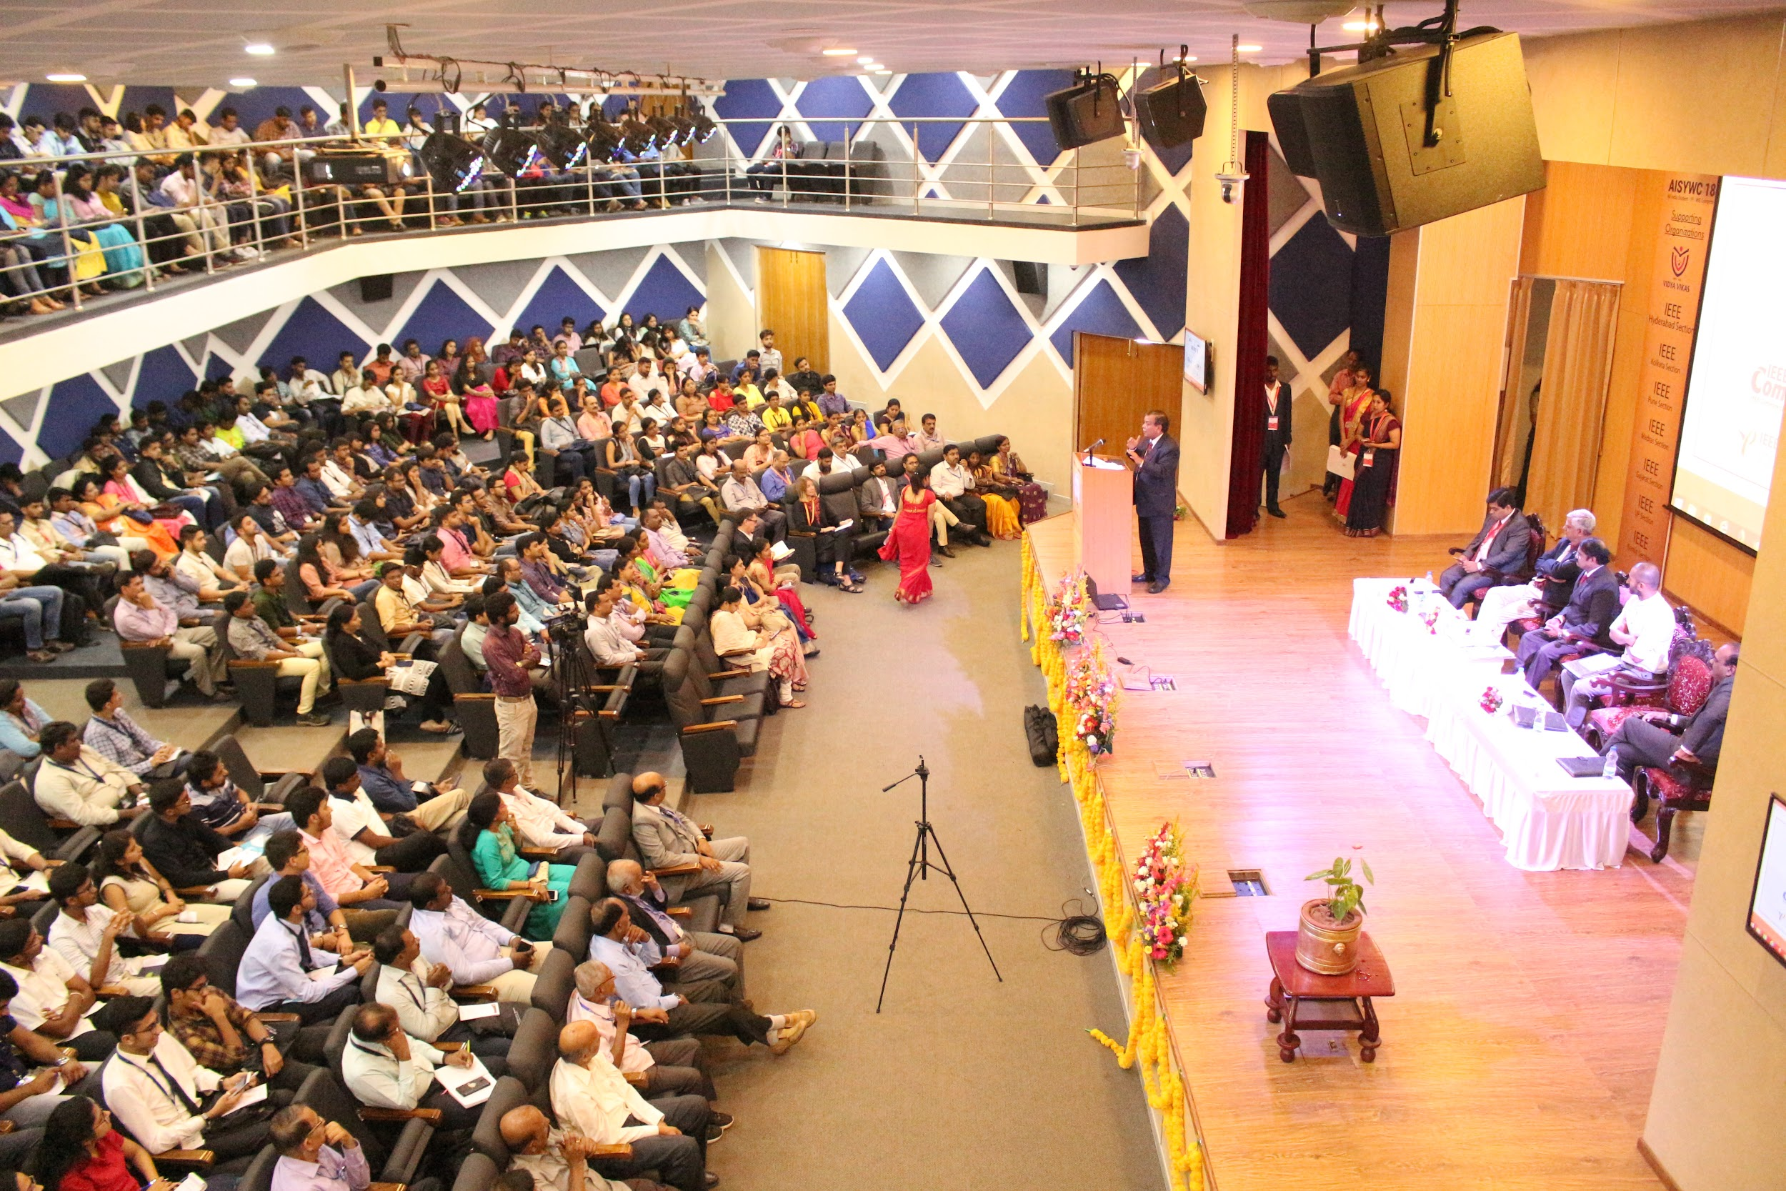
The plenary talk on Engineering Nature and Inside Story of Chandrayaan-1 and Mars Orbiter Mission by Dr. M Annadurai, Distinguished Scientist & Former Director, U R Rao Satellite Centre, ISRO explained briefly from the basics of the space to the stories of Chandrayaan covering the various technical aspects of the space vehicles another one by "Mental Competence for Self and National Development" was given By Hon’ble Justice N Kumar, Ret. Justice, High Court of Karnataka. The next keynote was by Daniel Lottis, SIGHT Chair, and later was an interesting session on Chasing your dreams and passion by a renowned Actor and an entrepreneur Miss. Padmaja Rao. Followed by which was a talk on Workshop on Skills for Employability by Sudeendra Koushik, Founder, Prasu. The session concluded with the talk on RF, Microwave Industry Trends and Road Map: Opportunities for Students, Young Professionals and Women in Engineering by Damodar M S, Entuple.

Student track
The tracks kicked off with talk by Anupama Gowda, the co-founder of workbench projects, the very first makerspace in Bangalore, continued to an informative session on introduction of societies PES, ComSoc, MTT-S and TEMS. Continued with inspiring sessions on Creativity & IPR by Dr. YVS Lakshmi,Stay Competent and Connected with IEEE by Kristen MacCartney, IEEE UPP, the IEEE Xplore Digital Library, Your Source of Emerging Technology by Dhanukumar Pattanashetti, IEEE Client Service. Remote Sensing - Opportunities by Munir Mohammed, Sr Program Manager, IEEE.IEEE BLP for Students by Malay Harsha, Sr Manager Blended Learning Program, HAM Introduction and Hands-On Workshop on Disaster Management.

Young Professionals Track
The power packed session started with “Introduction to IoT and its Challenges" by Nihal Kashinath Founder and CEO, Applied Singularity
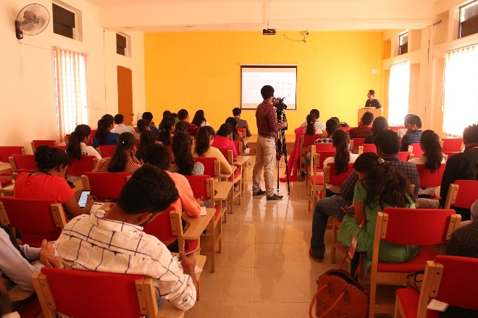
followed by TISP functions essentially as a professional development workshop aimed at helping teachers bring exciting hands-on engineering lessons into their classrooms continued How Storytelling, Design Thinking and Radical Innovation can help build sustainable communities, products and business by Rohan Goswami, COO & Director, Ycentre India. Then we had a talk on Understanding the Blockchain and its Use Case by Abhinav Ramesh, Founder & CEO WandX. The session on Building a Community of Young Professionals by Nivas Ravichandran, IEEE R10 Coordinator seemed extremely useful which lead to another wonderful talk on Best Practices of IEEE Bangalore Young Professionals by Abhishek Appaji from BMSCE. Then the last one on Building Technical Communities Through Entrepreneurship Activities in India by Dr Amit Kumar, Bio Axis DNA Research Centre.

Women in Engineering Track
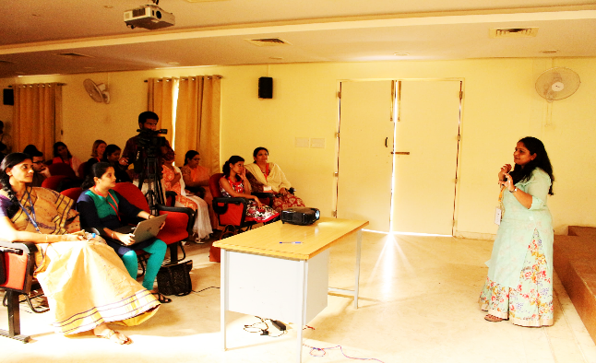
Ms. Chaya from Necter Fresh gave an inspiring session, her journey as a women entrepreneur, challenges and techniques which helped in creating an impactful brand in the society. Building Your Personal Brand by Vijaya K Matt, Workforce Diversity Program Manager, HR, IBM then “Truly Essential, yours truly” - Akshara Kumar, Founder, Truly Essential sharing her journey and experiences from design to product and the customer satisfaction. Women in Computing by Lakshmi Subramanian, TCS. WAPSI initiative of Thoughtworks, Gunjan Shukla, Thoughtworks on initiating and directing women in technology with career breaks. Opportunities and Excellence Recognition for Women in Science and Technology was a short discussion which helped participants to divulge into multiple perspectives of creating an inclusive atmosphere for women in science and technology. WIE Poster Session had an interactive participation sharing the research and information in their presentation.
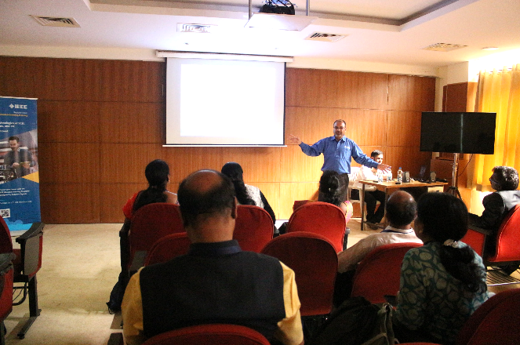

Branch Counsellors Track
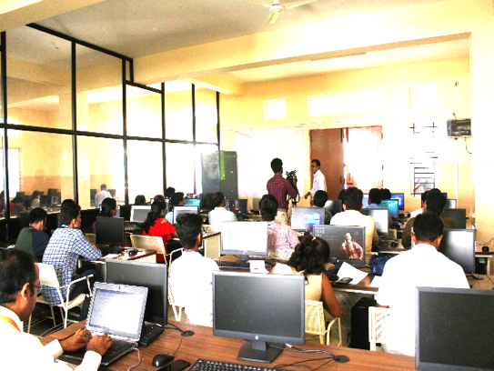
IOT Ecosystem and IEEE Standards by Sri Chandra, Sr. Director Standards & Technology IEEE discussed smart cities,Embedded Perspective by Gautham Sriprakash, Embedded/IOT Specialist, IEEE ,IEEE BLP for Student Branches by Malay Harsha, Sr Manager Blended Learning Program, IEEE ,TISP Workshop helped participants in understanding the functions essential for a professional development,BC Training by Shrikant Tangade Reva University discussed on influencing and shaping the minds of young, bright and energetic professionals around the world.

MTT-S hands on Workshop

Modeling and Simulation of Microwave Antennas & Devices has been conducted only for selected set of people and the workshop was hands on with four set of batches comprising of 30 attendees per batch.

Professional Night
Day 1 of AISYWC ’18 ended with a professional night where it was a night for all to suit up. The professional Night started with a Standup Comedy by Dr. Jagdish Chaturvedi, who is a dentist turned Standup Comedian. With roars of laughter everyone enjoyed the humor and fun being generated there. After that were few dance performances from Bangalore section which included fusion of Bharatanatyam and Kathak and various other dance forms which also included the famous fisherman’s dance from Mangalore Subsection. Everyone enjoyed the performances as they did bring color to the atmosphere.
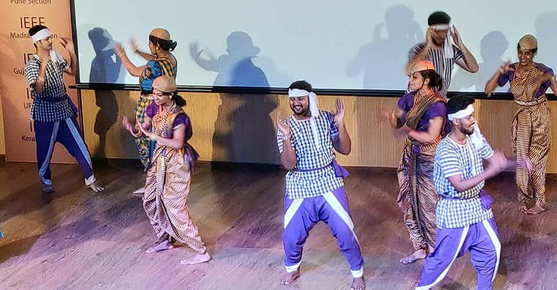
Day 1 one ended with Dinner and the delegates being dropped to their respective hotels.

Day 2 (29 September’18)

Day 2 of AISYWC started with a keynote by Puneet Kumar Mishra, General Chair, AISYWC’18 and from ISRO on “Antennas for Satellite Communication”. Followed by this were few other notable sessions by Ravikiran Annaswamy, Founder and Director of Innohobit Technologies on Entrepreurship and a design thinking workshop by Tathagat Varma, Country Head, Chinasoft. After the session by Prof. Debabrata Das, IIIT-B on How Wi-Fi Works, the morning sessions of Day 2 ended. The afternoon sessions after the lunch were again divided into multiple tracks like Day 1, like Student track, Young Professionals Track, Women in Engineering Track, Branch Councilors Track and MTS Hands on Workshop.

Cultural Night
After a full packed day with much learnings, the evening of Day 2 was dedicated just for enjoyment. It was the cultural night where all the delegates were requested to represent their respective states and culture from where they come from. Everyone was dresses in beautiful attires and the performances were too by each section, representing their dance forms, songs and videos exhibiting their culture. The best cultural performance was bagged by Delhi Section and the best Video contest went to Bangalore and Bombay Section.
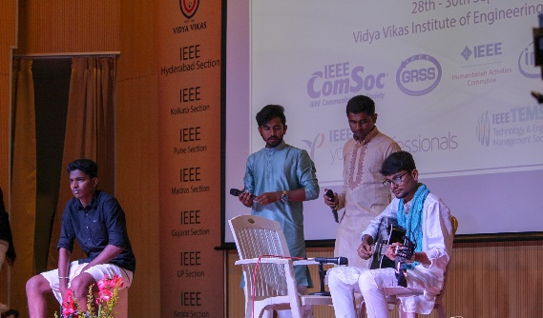
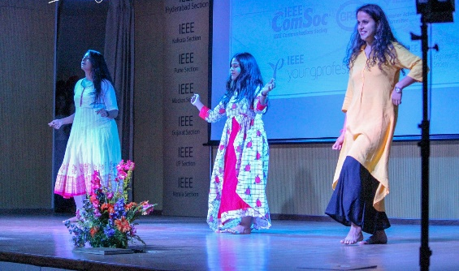
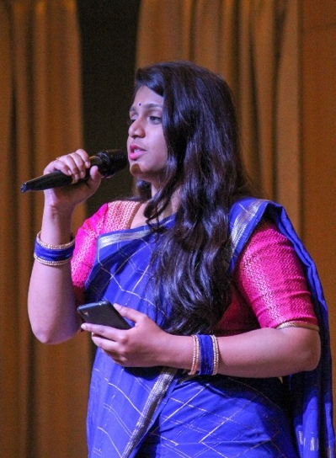
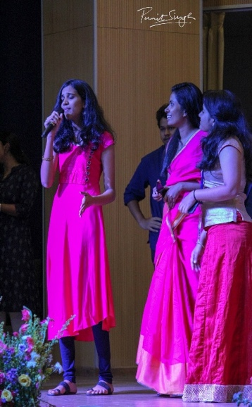
It was a night of enjoyment fun and photoshoots, Day 2 ended with dinner and dropping all attendees back to their respective hotels.
Day 3 (30 September’18)

Day 3 and the last day of the AISYWC’18 started with a Session on Project Management – A Life Skill By Lt Col L Shri Harsha followed by which a session on Role of Microwave Remote Sensing in Quantifying and Managing Subsurface Water Resources: Mahta Moghaddam, IEEE GRSS. After this was an interesting session by Dr. Balakrishna Shetty, VC, SAHE on Spirituality, Science and Ethics. Followed by this was a session on AI and ML in Healthcare by Dr Preeti Bajaj, Director, GHRCE & Secretary, IEEE India Council and How to Orgainize an IEEE Technical Conference and its Best Practices: Prof. S N Singh, Technical Conference Coordinator, IEEE Region 10, and VC, MMMTU.

Valedictory

The valedictory function began by inviting the dignitaries Prof. SN Singh, Dr. Sivaji Chakravorti, Mr. Kaveesh, Mr Sudeendra Koushik and Puneet Kumar Mishra on the stage. Mr Kaveesh was invited to speak a few words about the event. After this there were multiple awards given for the various contests conducted during the span of 3 days, which included Video contests, poster presentation contests, logo contest and Mysuru foodie activity contest for which a Fitbit was given as the prize. Following this was the felicitation of Prof SN Singh and Dr. Sivaji Chakravorti by IEEE Bangalore Section. Mr. Kaveesh was felicitated by the AISYWC team and then Mr Sudeendra Koushik and Puneet K Mishra was felicitated by Chair and Chair-Elect of IEEE India Council. The session ended with a vote of thanks and calling up all the volunteers who has tirelessly worked for months onto the stage for a photo.

Valedictory Session of AISYWC

