 | 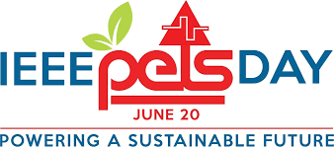 | 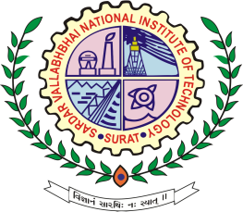

Expert Talk Organized by IEEE Gujarat Section PES/IAS/PELS Joint Chapter jointly with Electrical Engineering Society (EES), SVNIT, Surat.

On the occasion of IEEE PELS DAY 20th June 2022, an EXPERT talk on “Electronics in Power and Energy Systems – Changing Paradigms” was organized by IEEE Gujarat Section PES/IAS/PELS joint chapter and Electrical Engineering Society (EES), Sardar Vallabhbhai National Institute of Technology (SVNIT), Surat. The talk was organised in offline mode at the seminar room of new electrical department building, SVNIT, Surat between 10.30 AM to 12.00.

The expert talk started with the welcome address by Dr. Mahmadasraf Mulla, Vice Chair, IEEE Gujarat section’s PES/IAS/PELS joint chapter. The presentation was delivered by Dr. Vijay Shah, Vice President, Members International Team of R&D Experts Electrification Business, ABB, Vadodara; where he discussed the importance of the topic and inspired the participants to enrich their knowledge in different fields of use of electronics in power and energy systems. Dr. Vijay presented future use of electronics in distributed generation systems, DC transmission (HVDC-MVDC) systems, DC distribution (LVDC) systems, digital substations, advancements in monitoring and control, network topologies, eMobility, and product architecture. A major focus of this session was on the percolation of low power embedded electronics, high power, and efficient semiconductors availability, and emerging novel integration topologies that technological shift can bring fundamental change in the future power system. | 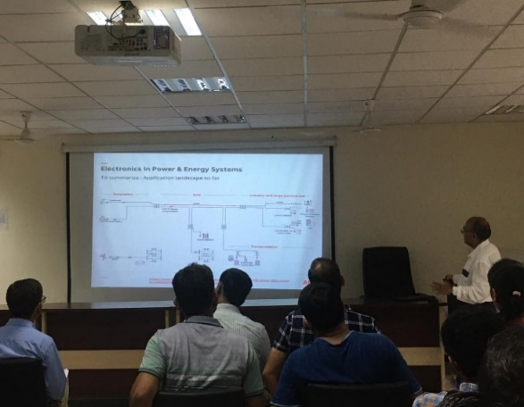  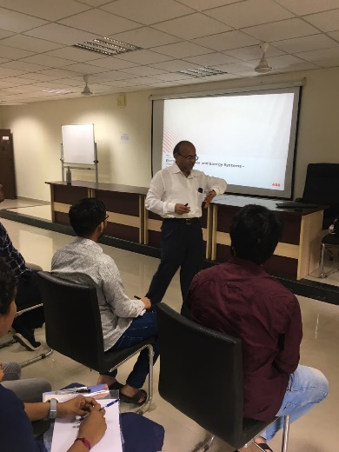
 | Session delivered by Dr. Vijay Shah

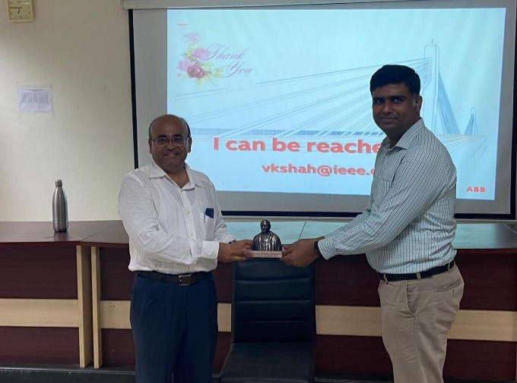 | 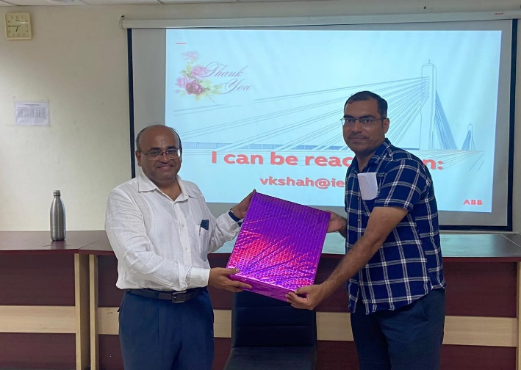
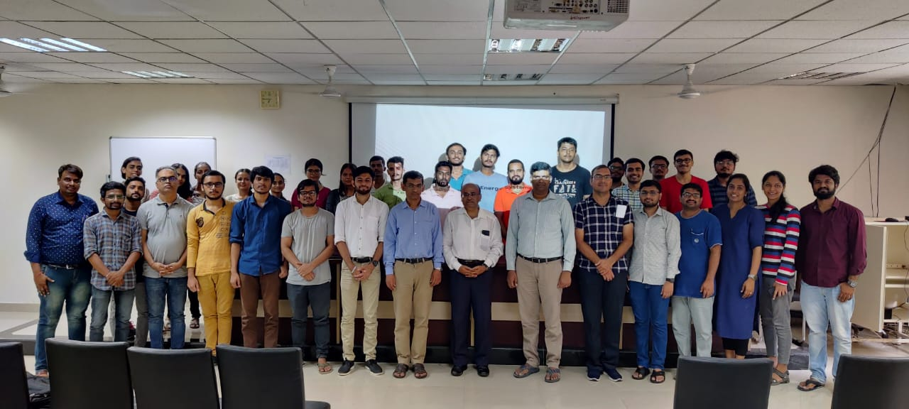
Group photograph of participants, research scholars, and faculty members with Dr. Vijay

At the end of the presentation session, an interactive Q & A session was held where students, research scholars, and faculty members were able to deliberate more about their queries with the expert.
The program concludes with Er. Kartik Dubey thanked the speaker for the insightful talk. Our guest speaker was presented with a memento and gift by Dr. Rajasekhara Reddy Chilipi and Dr. Sanjay Tolani (Assistant Professor, EED SVNIT).

