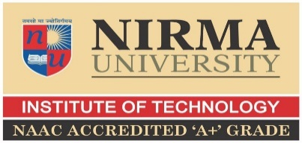

ROBOMANIA - 2022
R10 Robotics competition stage 1
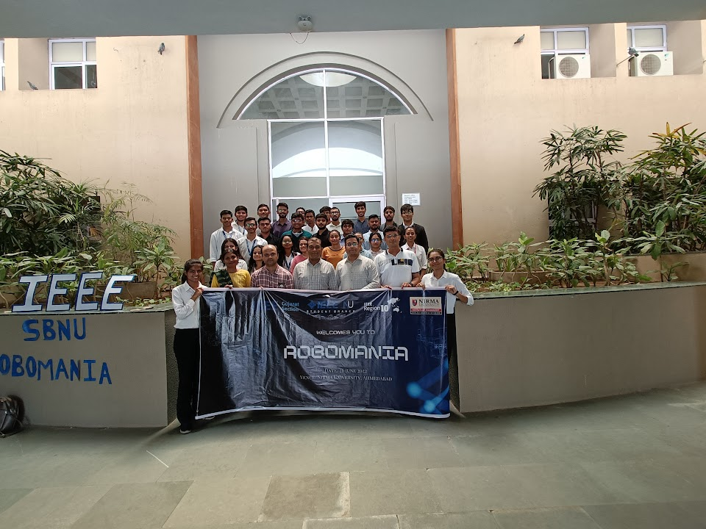

About RoboMania, 2022
‘Robomania’ - R10 Robotics competition Stage-1, an IEEE Gujarat Section event, hosted by IEEE Student Branch Nirma University on 26th of June 2022 at Nirma University, Ahmedabad. IEEE and its members inspire a global community through its highly cited publications, conferences, technology standards, and professional and educational activities. Robotic technology is common in industrial automation for physical tasks and represent an important support for humans to perform heavy repetitive tasks. The theme of the event was Modelling and Simulations for Robots development. It motivated students to develop Robotics for healthcare. Various perks of competiton also included :
- Exposure to science, technology, engineering, mathematics(STEM) and robotics
- Chance to build IEEE network with SBNU'S around the nation
- Opportunity to compete with SBNU's and get your name on global boards
- Expert session on Basics of Robotics
- IEEE Certificates for all
- Selected top two teams represent the section and compete at International level

It was a six-hour long event, from 9am – 3pm, which began with the registration. There was a registration charge of rs. 400 per team. It received a response of more than 10 teams and overall 40 participants from different Student Branches like - ADIT, NIRMA, GCET, SOU, DDU, etc

Publicity of Robomania 2022
Various things were done to promote the event. Event brochure was created for easy understanding of Robomania by the participants. Multiple mails including description and registration forms were sent to 850+ people and different universities like Nirma university, Charusat university, SVNIT, etc. Chairperson of various SB’s were approached to circulate the forms inside their colleges. Different social media platforms like Twitter, LinkedIn, Approaches to various IEEE pages were also made on Instagram. Multiple stories were posted to create hype and use of hashtags to increase the reach of the post. Taglines were used to make the event more attractive.
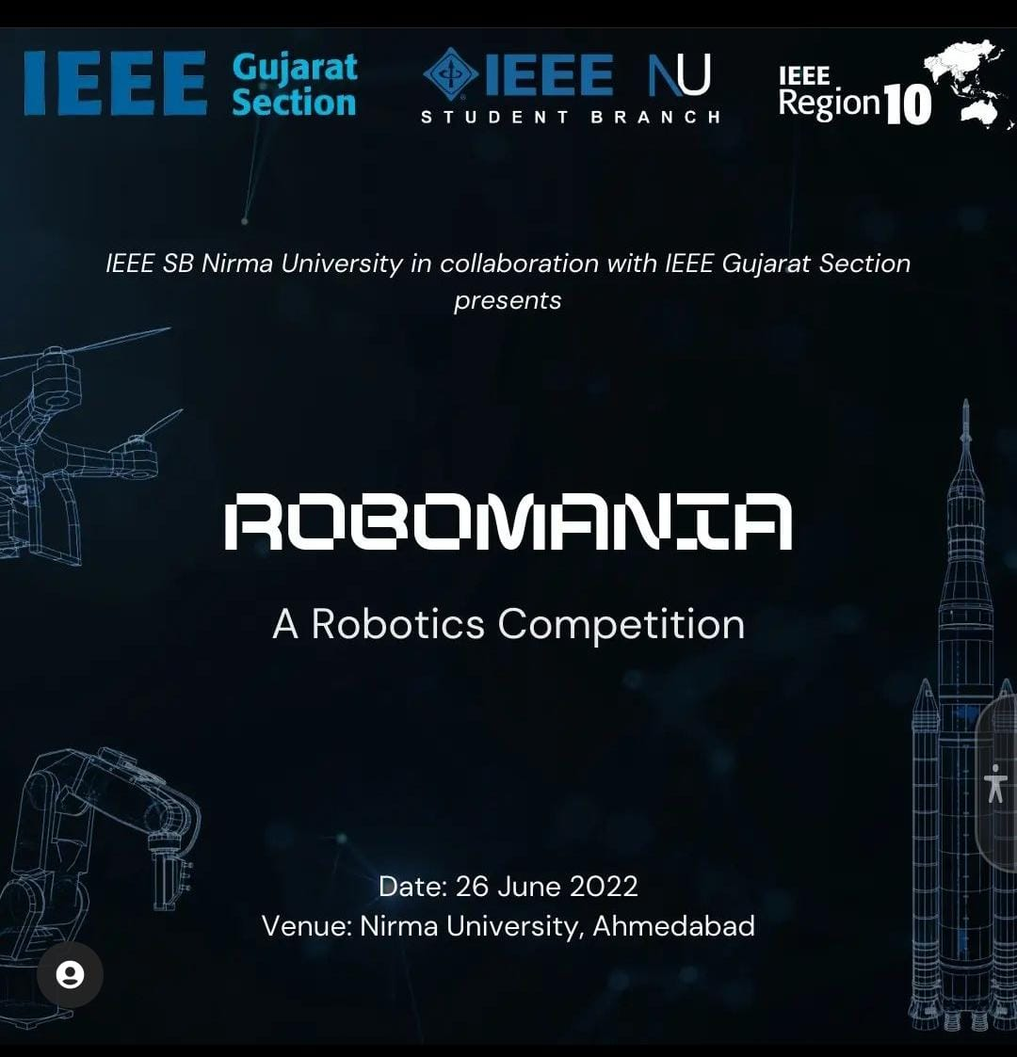

Instagram post for Robomania
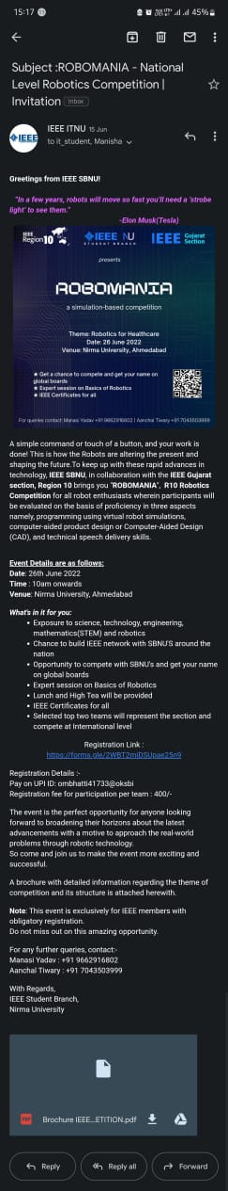

An IEEE Robomania mail
Event flow of Robomania 2022

SR. NO. | ACTIVITY | TIME
1 | Registration by the teams | 9.00 – 9.30 am
2 | High tea | 9.30 – 10.15 am
3 | Inaugural ceremony | 10.15 – 10.30 am
4 | Expert session | 10.30 – 11.15 am
5 | Evaluation of projects | 11.15 – 1.15 pm
6 | Lunch break | 1.15 – 2.15 pm
7 | Result declaration and vote of thanks | 2.15 – 3.00 pm

Jury of Robomania 2022
SR. NO. | NAME
1 | Mr. Nirav Patel (SAC, ISRO)
2 | Dr. Ashish Phophalia (IIIT, Vadodara)
3 | Dr Jatinkumar Dave (Nirma University)

Expert session of Robomania 2022
The event started with high tea followed by expert session from an expert of SAC ISRO ‘Mr. Nirav Patel’ on the subject of ‘Advancements in Robotics for Space Applications.’
He gave a splendid presentation that exposed students to the field practices. He explained students about Robotics, automation, building blocks of robots, field of applications, space applicability and space robots. He also threw light on scope and challenges. The intention of his presentation was to ignite young minds with new ideas and provide with insightful things on the culture of Robotics and automation.
Elimination round
This was followed by the elimination round which included presentation of the projects made by the participants in front of an esteemed jury, consisting of,
IEEE Gujarat Section Secretary (2022) - Dr. Ashish Phophalia
Associate Professor at Mechanical Department Nirma University – Dr Jatinkumar Dave
and our expert speaker from SAC ISRO – Mr. Nirav Patel
Several Student Branches from all over the Gujarat section participated enthusiastically in this competition. The evaluation was based on various criteria like creativity, understanding of the topic, relevance, presentation, plagiarism, etc. The jury came to the conclusion after various discussions among themselves.

Result declaration for Robomania stage1
After this, it was the time for lunch break which was followed by result announcement and vote of thanks. 5 teams out of 10 were eliminated and the top 5 teams were selected for second round of elimination. The 5 shortlisted team competed in the next round of elimination which was held on google meet “https://meet.google.com/gyz-myze-dfu” on 29th June 2022 ; out of which 3 were eliminated and 2 were selected for stage 2 of Robomania. Winner team Mandroid received an amazon gift voucher of Rs.2400 and the runner up team Robokicks received an amazon gift voucher of Rs.1600. The top 2 teams will compete in the stage 2 which is a international level competition. Later, all the participants received IEEE certificates and the jury and the speaker were presented with the mementos for the event as a token of gratitude.
Details of winner team
Team Mandroid
Sr. no. | Name | College
1 | Dhyan thakkar | Nirma
2 | Purva bhagwagar | Nirma
3 | Rishita chaliyawala | Nirma

Details of runner up team
Sr. no. | Name | College
1 | Anubhav sriwastava | GCET
2 | Ajay sorathiya | GCET
3 | Shreyansh agarwal | GCET
4 | Shayama kareliya | GCET

Glimpses of the event

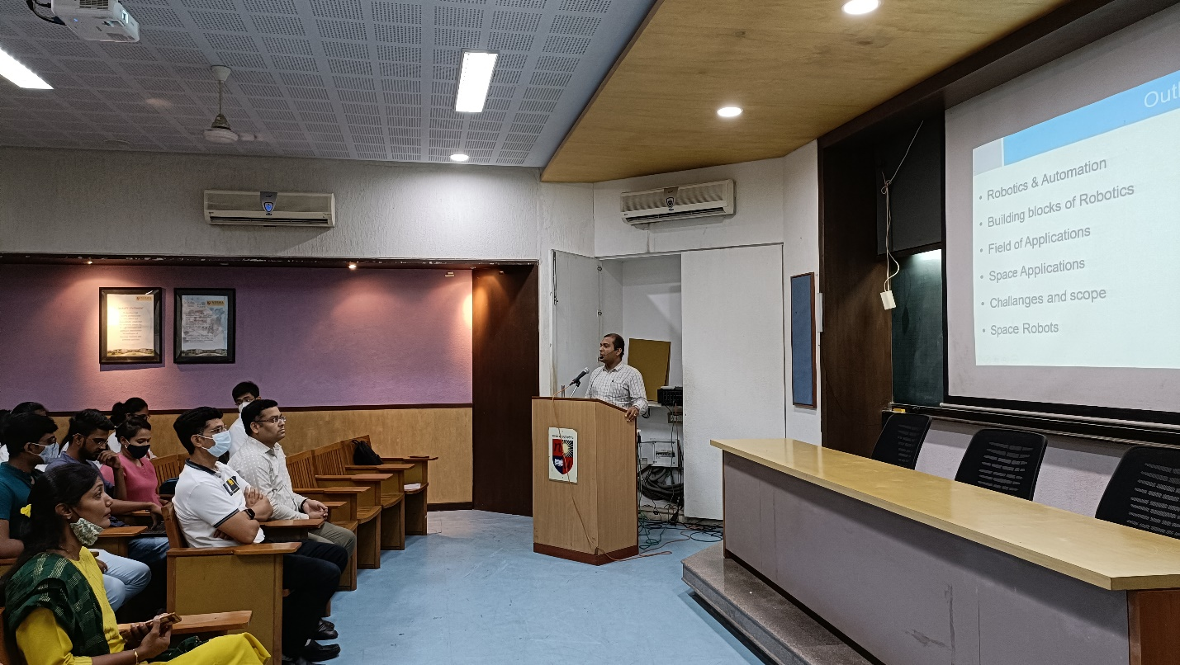

Mr. Nirav Patel delivering expert lecture

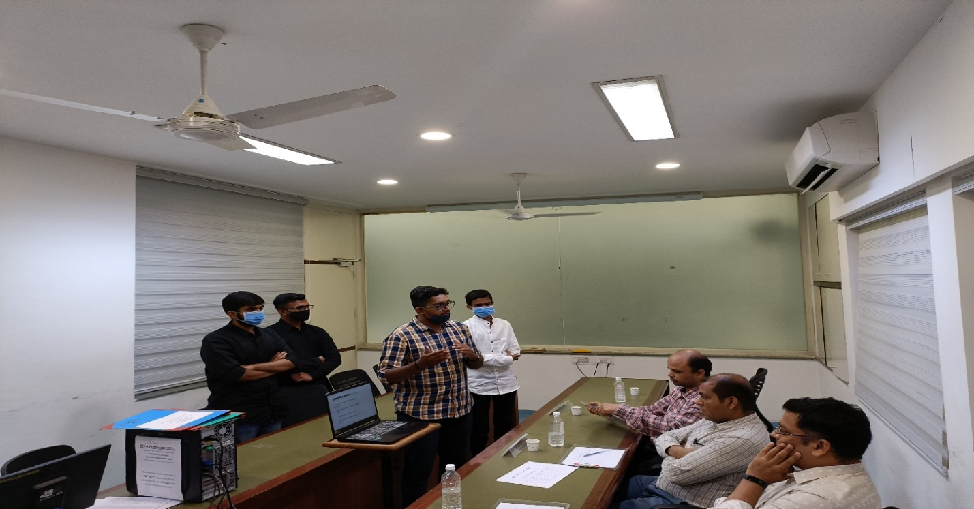

Presentation of the projects

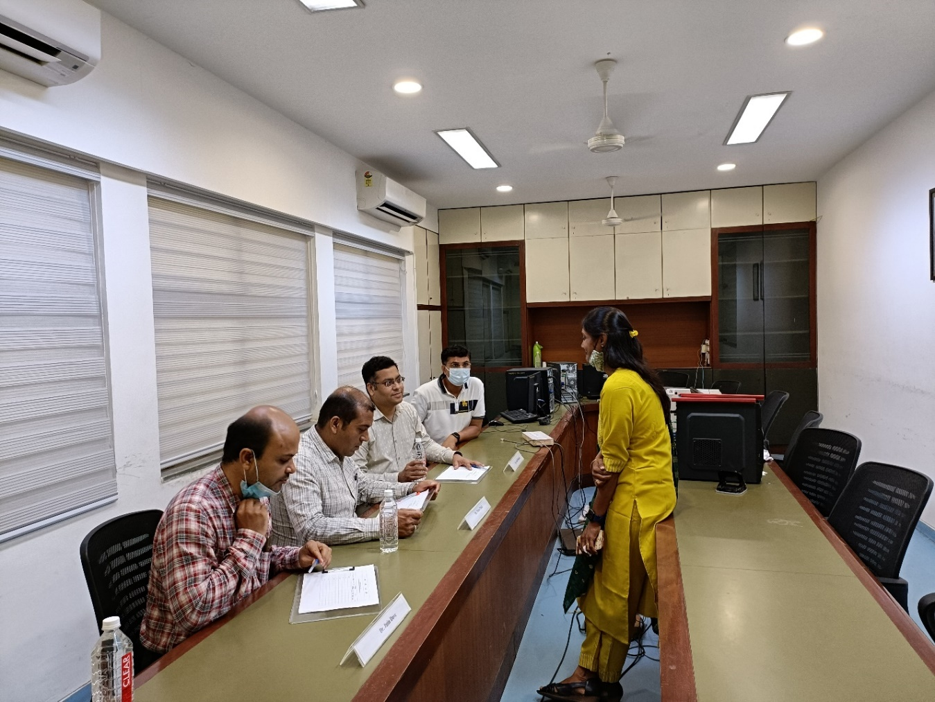
Jury evaluating the projects

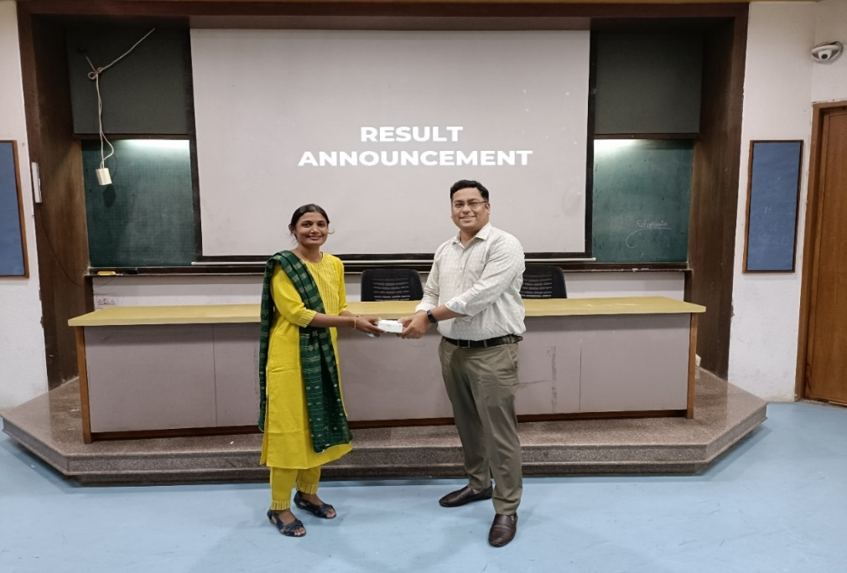
Ms. Manisha shah distributing awards and mementos

Banner for Robomania 2022, stage 1

