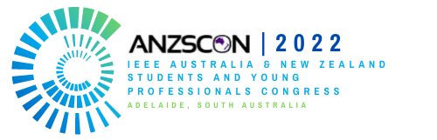

IEEE ANZSCON 2022 – NSW Delegate Registration Support Application Form
1 – 2 October 2022, South Australia

This application form should be sent to Syed Muzahir Abbas (syed.abbas@mq.edu.au) and Naila Mukhtar (naila.mukhtar@ieee.org) by Sunday, 14th August 2022 (closing date).
IEEE NSW Section will short list and awards funding to the selected candidates. The decision of the committee will be final and cannot be disputed.

Section A: Candidate Personal Details
Title:
Name:
Affiliation:
IEEE Member Number:
Email Address:
Telephone Number:
Current Position in the Section/Student Branch:
Volunteer Category: (select all applicable categories) | X | Student | X | Young Professional | X | WIE
Past IEEE Accomplishments:

Section B: Impact
State the purpose of attending ANZSCON and how it would be beneficial for your professional growth. (Max 300 words)

