IEEE SPAA Event Report

- IEEE Student Branch name : Sri Sairam Engineering College
- IEEE Student Branch Number :
- Name of the event : STEP 2020 - Discovering Your Professional Future
- Dates : 04 - 01 - 2020
- Venue : Leo Muthu Auditorium, SSR Hall
- City, State : Chennai, Tamil Nadu
- Country : India
- IEEE Region : R10

- Objectives and Motivation of the SPAA event (100 words):
The objectives and motivation of the SPAA event is
(a) To provide an understanding for the students about the different career opportunities available after the graduation,
(b) To connect students with the experts from the different professional path and
(c) To help the students see the value of IEEE Young Professionals; and how they can make use of the community.
- Event description (100 words):
The Inauguration of the event began with the Prayer song by student volunteers followed by which Prof. T. Sheela, HOD of Information Technology welcomed the gathering. Dr. A. Rajendra Prasad, Principal of Sri SaiRam Engineering College in his Special Address, mentioned the importance of being an IEEE Member. Dr. J. Raja, HOD of Electronics and Communication Engineering delivered the Keynote Address. Er. M. Arun, Vice Chair of IEEE Madras Young Professionals gave a brief outline about the Societies and Fundings available in IEEE, following which Dr. M. Venkatesh Kumar, Immediate Past Chair of IEEE Madras Young Professionals delivered a talk on IEEE Young Professionals. Er. Ashvanth B., Treasurer of IEEE Madras Young Professionals talked about STEP and how it helps in the professional growth of the graduating student members. Er. Brindha, Associate Professor of ECE delivered the Vote of Thanks. The Richard E Merwin scholar Mr. Leoram of Sri SaiRam Engineering College shared his experiences with IEEE. The Inauguration ceremony ended with the IEEE Code of Ethics.
The event included 8 keynote sessions on the following areas: Entrepreneurship, Non-Profit Organization, Research, Teaching, Corporate Management, Higher Studies, Skill Building and A Big Picture of IEEE YP. There was also a YP panel of 5 members which addressed the queries of the participants.
a. Name of the speakers along with their brief profile:
i. Mr. Harish Srinivasan Co-Founder of Infinite Engineers.
ii. Dr. M. Venkatesh Kumar, Associate Editor of IEEE Access Journal
iii. Mr. Gowtham Kumar, Recruitment Lead of Teach for India
iv. Mr. Arun M., Assistant Professor of Panimalar Institute of Technology.
v. Mr. Vinod Sharma, Key Account Manager, Emerging Enterprises at Siemens
vi. Mr. Sudharshan R., Research Scholar at IIT Madras
vii. Mr. Vamsi Krishna Mula, Business Analyst at McKinsey & Co
viii. Mr. Aravindhan Anbazhagan, City Development Associate, TFI.
ix. Mr. Ashvanth B., Treasurer of IEEE MAS YP
x. Ms. Pooja Sharma, Execom Member of IEEE MAS YP,
xi. Ms. Karthika A. S., Secretary of IEEE MAS YP
xii. Mr. Eniyan, Student Lead of IEEE TEMS India
xiii. Mr. Abdul Halik, Execom Member of IEEE MAS YP and Member of IEEE Madras PSES
b. Number of attendees attended:
i. IEEE Members:50
ii. Non-IEEE Members:77
- Event pictures/photos (attach some photos here)

Link of the photos: STEP 2020 Photo Link Drive

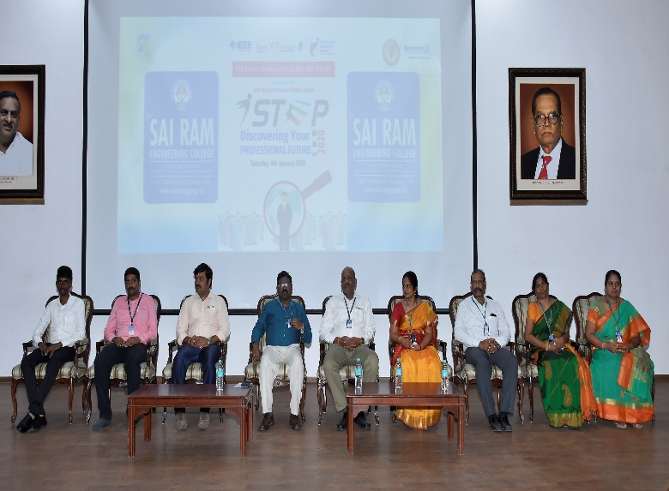 | 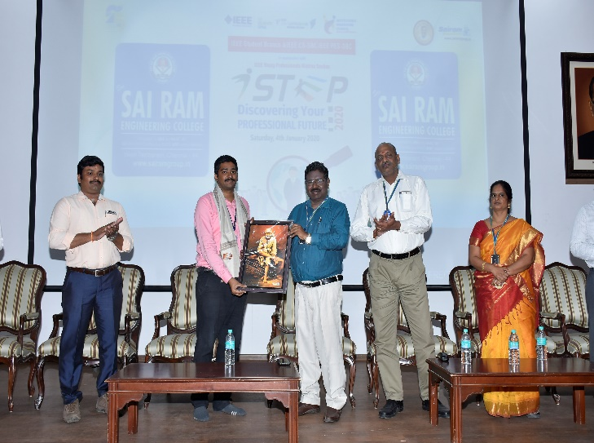
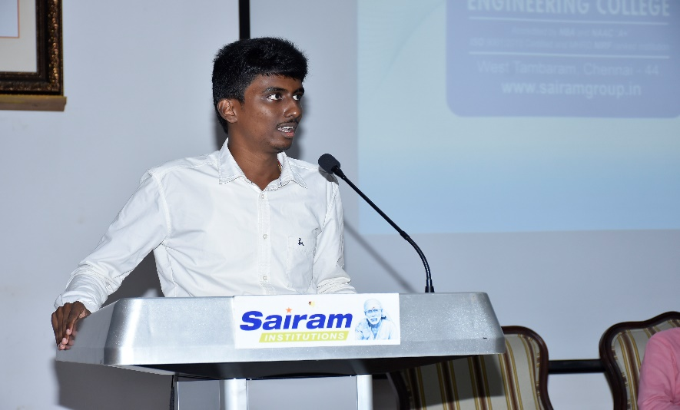 | 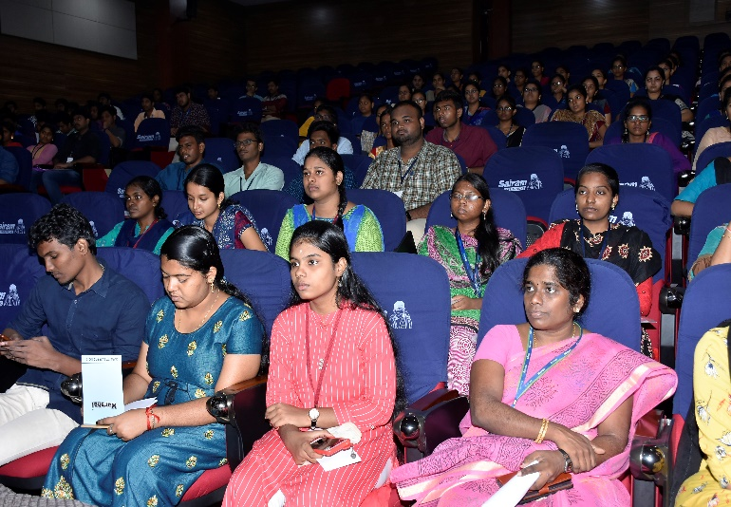
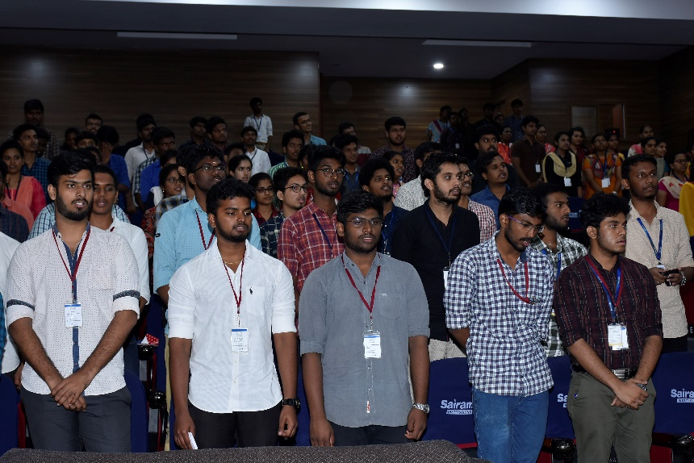 | 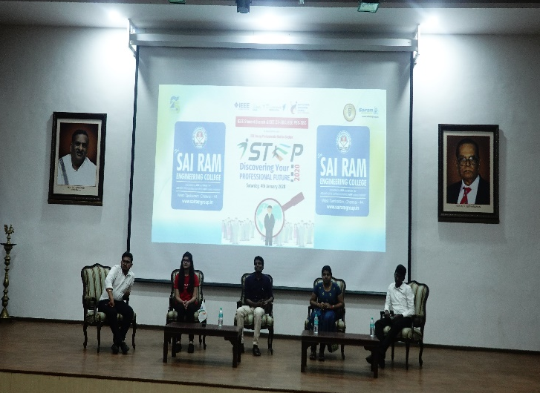
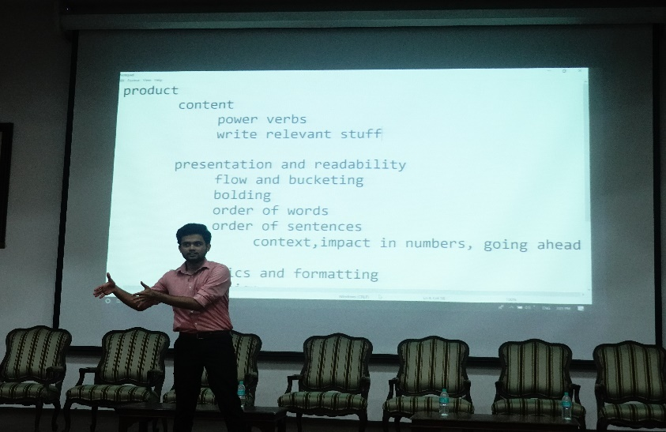 | 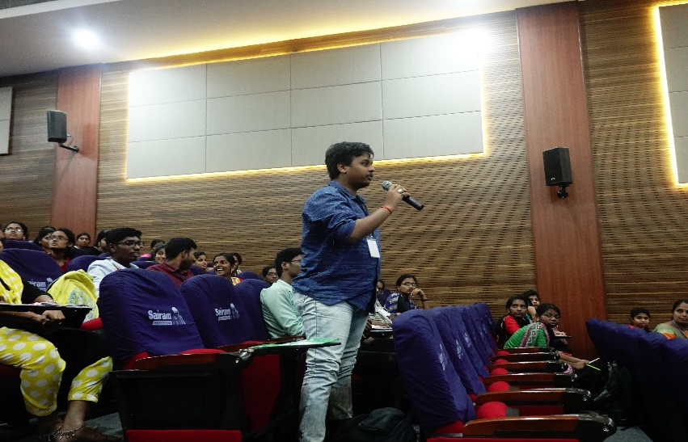
I certify that the report compiled by me is correct to my knowledge.
Student Branch Chapter Representative:
Place:
Date:

