IEEE Women In Engineering(WIE)
Ahmedabad University
Student Branch

Virtual Marathonology –
A Step Towards
Gender Integrity

Date: March 8, 2021
Time: 6 AM to 10 PM
Women In Engineering (WIE) Affinity Group of IEEE Ahmedabad University Student Branch in collaboration with Women In Engineering (WIE) Gujarat Section organised an event “Marathonology – A Step Towards Gender Integrity” sponsored by ultrapop on the occasion of International Women’s Day held on March 8, 2021. The event witnessed 280+ registrations among various types like walking, running and cycling in different categories such as 3km, 5km and 7km. The participants showed great enthusiasm on the day of the event by sharing their photos and videos. Overall 180+ submissions were received and winners for each type and category were declared where in the first position winners were given trophies and the runner up position winners were given medals. The funds raised through the event were donated to AWAG (Ahmedabad Women Action Group) in order to celebrate the occasion with a social cause.

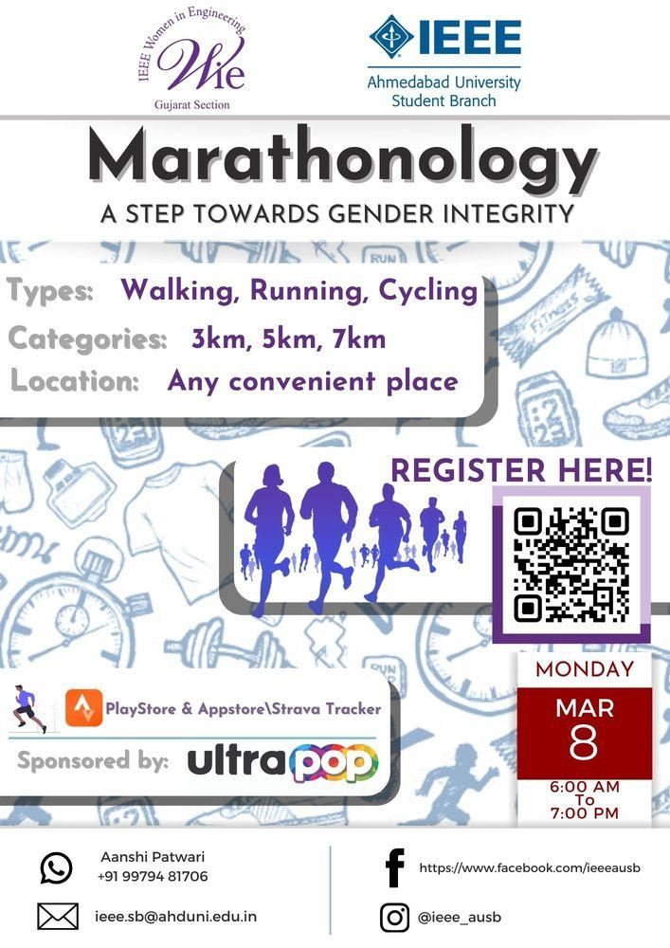

Date: March 8, 2021
Photos
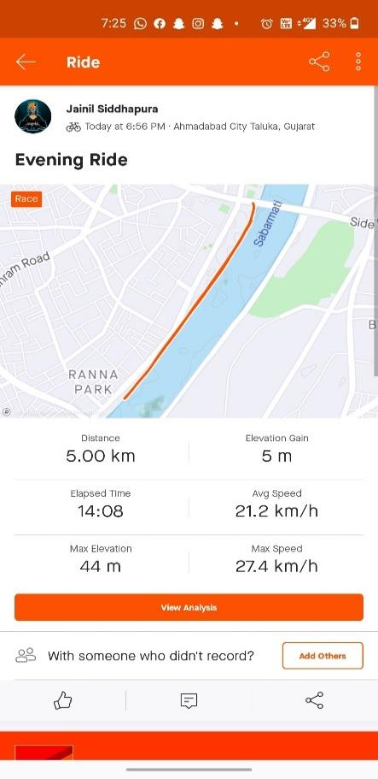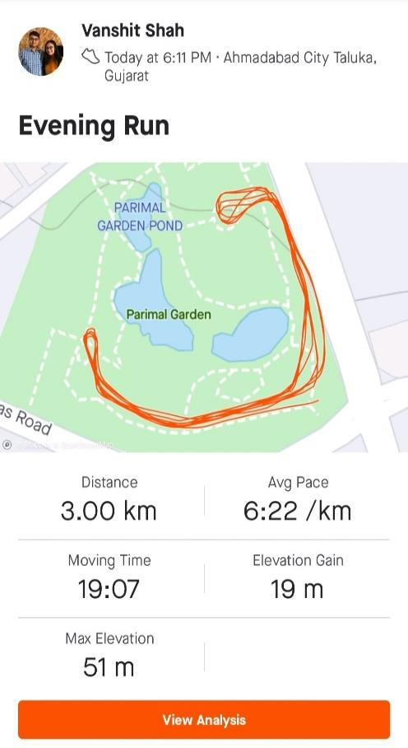
Winners

First Position Holders
No. | Name | Type | km | City
1 | Astha Bhalodiya | Walking | 3 | Surat
2 | Suverna Trivedi | Walking | 5 | Odisha
3 | Akash Prasad | Walking | 7 | Gandhinagar
4 | Madhvendrasinh Jhala | Running | 3 | Sudrendranagar
5 | Ayush Panara | Running | 5 | Ahmedabad
6 | Vatsal Patwari | Running | 7 | Ahmedabad
7 | Mahek Gohel | Cycling | 3 | Surat
8 | Jainil Sidhhapura | Cycling | 5 | Ahmedabad
9 | Nihar Kalolia | Cycling | 7 | Ahmedabad

First Runner-up Position Holders
No. | Name | Type | km | City
1 | Harshal Trivedi | Walking | 3 | Ahmedabad
2 | Nishi Jain | Walking | 5 | Ahmedabad
3 | Shaili Gandhi | Walking | 7 | Bharuch
4 | Vanshit Shah | Running | 3 | Ahmedabad
5 | Krupa Prajapati | Running | 5 | Anand
6 | Swasti Khurana | Running | 7 | Jaipur
7 | Keyur Khatri | Cycling | 3 | Ahmedabad
8 | Janki Kotadiya | Cycling | 5 | Ahmedabad
9 | Priyanshu Pathak | Cycling | 7 | Ahmedabad

Supporting WIE Student Branches
Following SBs have helped in conducting the event
- IEEE WIE Marwadi Education Foundation’s Group of Institutions Student Branch
- IEEE WIE Silver Oak University Student Branch
- IEEE WIE Madhuben and Bhanubhai Patel Institute of Technology Student Branch
- IEEE WIE Nirma University Student Branch

Volunteers
- Aanshi Patwari (Chair, IEEE WIE AU SB)
- Kripa Kundaliya (Vice chair, IEEE WIE MEFGI SB)
- Maharsh Patel (Chair, IEEE WIE SOU SB)
- Darsh Bhatt (Vice chair, IEEE WIE SOU SB)
- Aayushi Shah (Chair, IEEE WIE MBIT SB)
- Happy Aghera (Vice chair, IEEE WIE MBIT SB)
- Urja Patel (Chair, IEEE WIE NU SB)
- Raj Patel (Treasurer, IEEE WIE AU SB)
- Miracle Rindani (Chair, IEEE AU SB)
- Manav Vagrecha (Chair, IEEE RAS AU SB)
- Nityam Dixit (Tech Team, IEEE AU SB)
- Zalak Shah (Tech Team, IEEE AU SB)
- Shubham Jain (Tech Team, IEEE AU SB)
- Harshrajsinh Vaghrola (Treasurer, IEEE AU SB)
- Gaurav Bajaj (Vice chair, IEEE AU SB)
- Homak Patel (Vice chair, IEEE RAS AU SB)
- Aditi Vasa (Tech Team, IEEE AU SB)

